**Swagger Endpoints**

**Unit Tests**

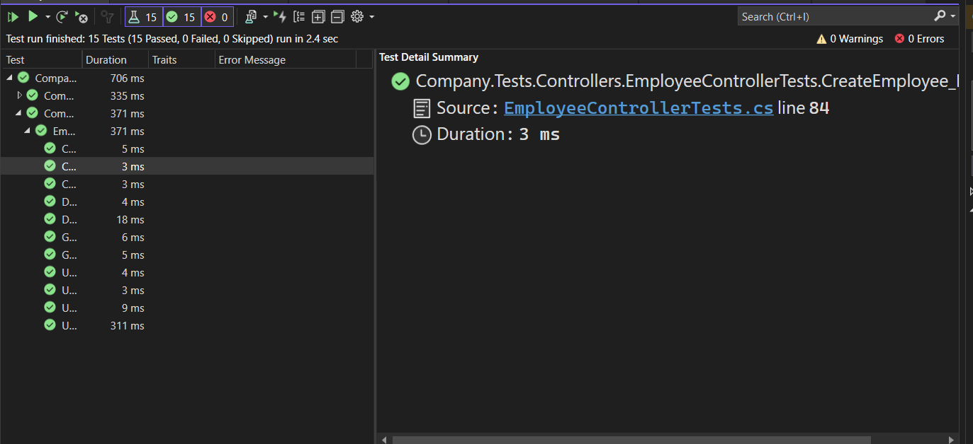

**Seeded Database:**

**Table: Employee**

**Table: Department**

**Employee Endpoints**:

**Getting Employee By Id:**

**https://localhost:7192/api/Employee/3**

**Get Employee By First Name and Last Name (Extra Credit) :**

**https://localhost:7192/api/Employee/FirstName/Test4/LastName/Employee4**

**Getting All Employees with their departments**

**https://localhost:7192/api/Employee**

**Posting Employee**

[**https://localhost:7192/api/Employee**](https://localhost:7192/api/Employee)

**Part 1:**

**Part 2: Newly posted Employee in DB**

**Exception when posting employee with exististing First Name, Last Name and Email**

**Deleting an employee**

**https://localhost:7192/api/Employee/5**

**Part1: Deleting from Swagger**

**Part 2 : Deleted from DB**

**Department Endpoints:**

**Getting Seeded Department By ID**

**https://localhost:7192/api/Department/1**  
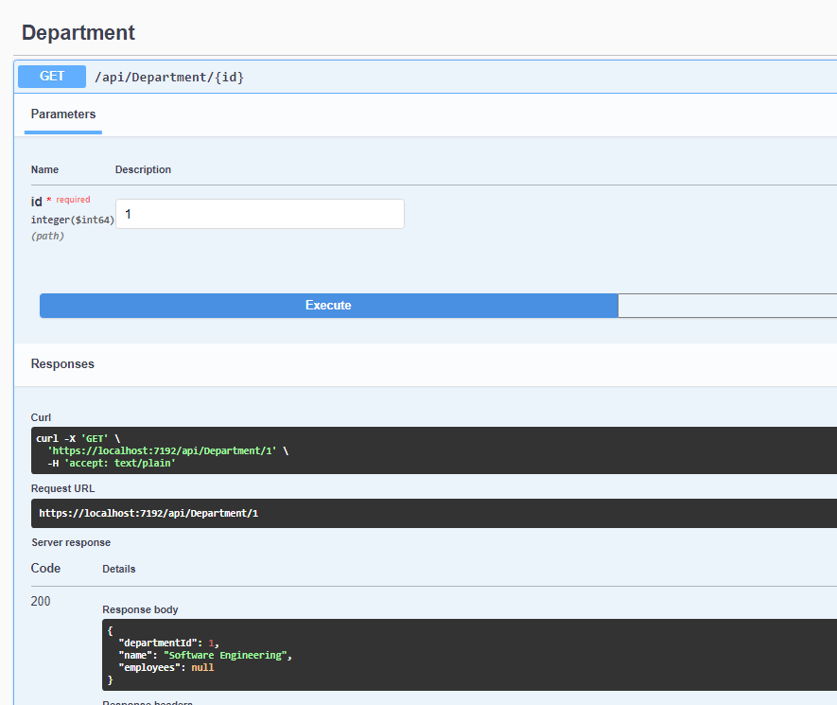

**Getting All Departments**

**https://localhost:7192/api/Department**

**Posting Department**

**https://localhost:7192/api/Department**

**Updating Department**

